Question 3 – Product Dataset Integration
An e-commerce company maintains product information in Supplier, Warehouse,
and Online Store datasets. Product names, product codes, prices, categories, and
stock quantities are represented differently across the datasets. Some records are
duplicated or contain spelling errors and invalid product codes.
Task: Develop a Python-based data cleanup and integration solution. Use RegEx to
validate product codes, fuzzy matching to identify similar product names,
duplicate detection, standardization of categories, outlier detection for prices,
and normalization of numerical values. Integrate the datasets and generate a final
product master file in CSV and JSON formats.

import pandas as pd
import numpy as np
import re
from difflib import SequenceMatcher
supplier = pd.read_csv("Supplier.csv")
warehouse = pd.read_csv("Warehouse.csv")
online = pd.read_csv("OnlineStore.csv")
print("Supplier Dataset:")
print(supplier)
print("\nWarehouse Dataset:")
print(warehouse)
print("\nOnline Store Dataset:")
print(online)
def standardize_columns(df):
df.columns = (
df.columns
.str.strip()
.str.lower()
.str.replace(" ", "_")
)
return df
supplier = standardize_columns(supplier)
warehouse = standardize_columns(warehouse)
online = standardize_columns(online)
def clean_product_name(name):
if pd.isna(name):
return ""

name = str(name).strip().lower()

# Remove extra spaces
name = re.sub(r"\s+", " ", name)

return name

for df in [supplier, warehouse, online]:
df["productname"] = df["productname"].apply(clean_product_name)
pattern = r"^(P\d{3}|PRD-\d{3})$"
def validate_product_code(code):
if pd.isna(code):
return False
return bool(re.match(pattern, str(code).upper()))
for df in [supplier, warehouse, online]:
df["productcode"] = (
df["productcode"]
.astype(str)
.str.upper()
.str.strip()
)
df["valid_product_code"] = df["productcode"].apply(
validate_product_code
)
def standardize_product_code(code):
code = str(code).upper().strip()
if code.startswith("PRD-"):
number = code.replace("PRD-", "")
return "P" + number
return code
for df in [supplier, warehouse, online]:
df["productcode"] = df["productcode"].apply(
standardize_product_code
)
category_mapping = {
"electronic": "Electronics",
"electronics": "Electronics",
"electronic devices": "Electronics",

"shoe": "Footwear",
"shoes": "Footwear",
"footwear": "Footwear",

"clothing": "Fashion",
"fashion": "Fashion",
"apparel": "Fashion",

"mobile": "Mobiles",
"mobiles": "Mobiles"
}
def standardize_category(category):
if pd.isna(category):
return "Unknown"
category = str(category).strip().lower()
return category_mapping.get(
category,
category.title()
)
for df in [supplier, warehouse, online]:
df["category"] = df["category"].apply(
standardize_category
)
def similarity(a, b):

return SequenceMatcher(
None,
str(a),
str(b)
).ratio()
def find_similar_products(df, threshold=0.80):
products = df["productname"].unique()
matches = []
for i in range(len(products)):
for j in range(i + 1, len(products)):
score = similarity(
products[i],
products[j]
)
if score >= threshold:
matches.append(
(
products[i],
products[j],
round(score, 2)
)
)

return matches

print("\nSimilar Product Names:")

all_products = pd.concat(
[supplier, warehouse, online],
ignore_index=True
)

matches = find_similar_products(all_products)

for match in matches:
print(match)
supplier = supplier.drop_duplicates(
subset=["productcode"],
keep="first"
)

warehouse = warehouse.drop_duplicates(
subset=["productcode"],
keep="first"
)

online = online.drop_duplicates(
subset=["productcode"],
keep="first"
)
for df in [supplier, warehouse, online]:

df["productname"] = df["productname"].fillna(
"Unknown Product"
)

df["category"] = df["category"].fillna(
"Unknown"
)

df["price"] = pd.to_numeric(
df["price"],
errors="coerce"
)

df["stock"] = pd.to_numeric(
df["stock"],
errors="coerce"
)

df["price"] = df["price"].fillna(
df["price"].median()
)

df["stock"] = df["stock"].fillna(0)
Q1 = all_products["price"].quantile(0.25)
Q3 = all_products["price"].quantile(0.75)

IQR = Q3 - Q1

lower_limit = Q1 - 1.5 * IQR
upper_limit = Q3 + 1.5 * IQR

all_products["price_outlier"] = (
(all_products["price"] < lower_limit) |
(all_products["price"] > upper_limit)
)

print("\nPrice Outliers:")
print(
all_products[
all_products["price_outlier"]
]
)

def min_max_normalization(series):

minimum = series.min()
maximum = series.max()

if maximum == minimum:
return 0

return (series - minimum) / (maximum - minimum)

all_products["price_normalized"] = (
min_max_normalization(
all_products["price"]
)
)

all_products["stock_normalized"] = (
min_max_normalization(
all_products["stock"]
)
)

combined = pd.concat(
[
supplier,
warehouse,
online
],
ignore_index=True
)
master = (
combined
.groupby("productcode")
.agg(
productname=("productname", "first"),
price=("price", "mean"),
category=("category", "first"),
stock=("stock", "sum")
)
.reset_index()
)

master["price_normalized"] = (
min_max_normalization(
master["price"]
)
)

master["stock_normalized"] = (
min_max_normalization(
master["stock"]
)
)

master.to_csv(
"Product_Master.csv",
index=False
)

master.to_json(
"Product_Master.json",
orient="records",
indent=4
)

print("\nFinal Product Master Dataset:")
print(master)

print("\nFiles created successfully:")
print("Product_Master.csv")
print("Product_Master.json")

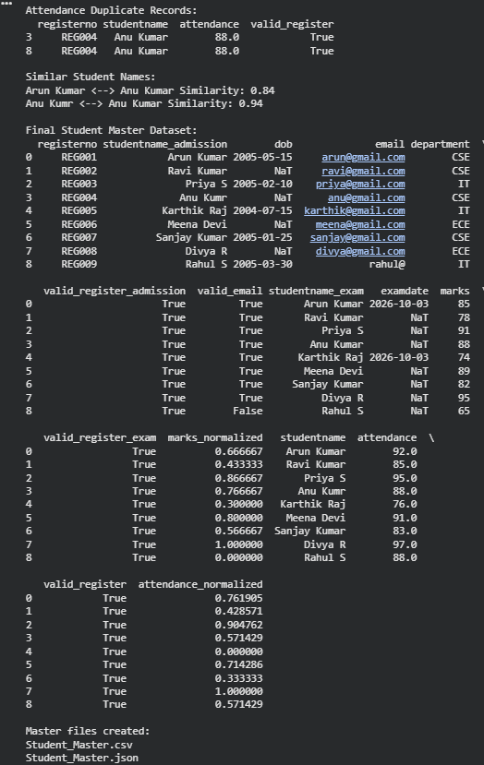

Question 4 – Student Dataset Integration
A college maintains student information in Admission, Examination, and
Attendance datasets. Student names have spelling variations, register numbers have
different formats, dates are inconsistent, email addresses may be invalid, and
duplicate student records exist.
Task: Using Python/Pandas, clean and integrate the datasets by applying data
formatting, missing-value handling, RegEx matching, fuzzy matching, duplicate
identification, normalization, and standardization. Create a master student dataset
and write a reusable Python cleanup script. Test the script with a new set of student
records.
import pandas as pd
import re
from difflib import SequenceMatcher
admission = pd.read_csv("Admission.csv")
examination = pd.read_csv("Examination.csv")
attendance = pd.read_csv("Attendance.csv")

def standardize_columns(df):

df.columns = (
df.columns
.str.strip()
.str.lower()
.str.replace(" ", "_")
)

return df

admission = standardize_columns(admission)
examination = standardize_columns(examination)
attendance = standardize_columns(attendance)

def clean_name(name):

if pd.isna(name):
return ""

name = str(name).strip().lower()

# Remove extra spaces
name = re.sub(r"\s+", " ", name)

# Remove unwanted characters
name = re.sub(r"[^a-z ]", "", name)

return name.title()

for df in [admission, examination, attendance]:

df["studentname"] = df["studentname"].apply(
clean_name
)

def clean_register_number(reg):

if pd.isna(reg):
return ""

reg = str(reg).upper().strip()

# Remove REG-, REG and spaces
reg = re.sub(r"^REG[- ]?", "", reg)

# Remove non-numeric characters
reg = re.sub(r"\D", "", reg)

# Add standard format
return "REG" + reg.zfill(3)

for df in [admission, examination, attendance]:
# Handle possible spelling in column name first
if "registernо" not in df.columns and "registerno" in df.columns:
df.rename(
columns={"registerno": "registernо"},
inplace=True
)
# Now that the column name is standardized (or confirmed), proceed with operations
if "registernо" in df.columns:
df["registernо"] = df["registernо"].astype(str)
df["registernо"] = df["registernо"].apply(
clean_register_number
)
register_pattern = r"^REG\d{3}$"

def validate_register_number(reg):

return bool(
re.match(
register_pattern,
str(reg)
)
)

for df in [admission, examination, attendance]:

df["valid_register"] = (
df["registernо"]
.apply(validate_register_number)
)

email_pattern = (
r"^[A-Za-z0-9._%+-]+@"
r"[A-Za-z0-9.-]+\."
r"[A-Za-z]{2,}$"
)

def validate_email(email):

if pd.isna(email):
return False

return bool(
re.match(
email_pattern,
str(email)
)
)

if "email" in admission.columns:

admission["valid_email"] = (
admission["email"]
.apply(validate_email)
)

if "dob" in admission.columns:

admission["dob"] = pd.to_datetime(
admission["dob"],
errors="coerce",
dayfirst=True
)

if "examdate" in examination.columns:

examination["examdate"] = pd.to_datetime(
examination["examdate"],
errors="coerce",
dayfirst=True
)

for df in [admission, examination, attendance]:

df.fillna(
{
"studentname": "Unknown",
},
inplace=True
)

if "email" in admission.columns:

admission["email"] = admission["email"].fillna(
"unknown@email.com"
)

if "department" in admission.columns:

admission["department"] = admission["department"].fillna(
"Unknown"
)

if "marks" in examination.columns:

examination["marks"] = pd.to_numeric(
examination["marks"],
errors="coerce"
)

examination["marks"] = examination["marks"].fillna(
examination["marks"].median()
)

if "attendance" in attendance.columns:

attendance["attendance"] = pd.to_numeric(
attendance["attendance"],
errors="coerce"
)

attendance["attendance"] = attendance["attendance"].fillna(
attendance["attendance"].median()
)

# ---------------------------------------------------------
# 9. DUPLICATE DETECTION
# ---------------------------------------------------------

print("\nAdmission Duplicate Records:")
print(
admission[
admission.duplicated(
subset=["registernо"],
keep=False
)
]
)

print("\nExamination Duplicate Records:")
print(
examination[
examination.duplicated(
subset=["registernо"],
keep=False
)
]
)

print("\nAttendance Duplicate Records:")
print(
attendance[
attendance.duplicated(
subset=["registernо"],
keep=False
)
]
)

# Remove duplicates

admission = admission.drop_duplicates(
subset=["registernо"],
keep="first"
)

examination = examination.drop_duplicates(
subset=["registernо"],
keep="first"
)

attendance = attendance.drop_duplicates(
subset=["registernо"],
keep="first"
)
def similarity(name1, name2):

return SequenceMatcher(
None,
str(name1).lower(),
str(name2).lower()
).ratio()

all_names = pd.concat(
[
admission["studentname"],
examination["studentname"],
attendance["studentname"]
]
).dropna().unique()

print("\nSimilar Student Names:")

for i in range(len(all_names)):

for j in range(i + 1, len(all_names)):

score = similarity(
all_names[i],
all_names[j]
)

if score >= 0.80 and all_names[i] != all_names[j]:

print(
all_names[i],
"<-->",
all_names[j],
"Similarity:",
round(score, 2)
)

def min_max_normalize(series):

minimum = series.min()
maximum = series.max()

if maximum == minimum:
return 0

return (
(series - minimum) /
(maximum - minimum)
)
if "marks" in examination.columns:

examination["marks_normalized"] = (
min_max_normalize(
examination["marks"]
)
)
if "attendance" in attendance.columns:
attendance["attendance_normalized"] = (
min_max_normalize(
attendance["attendance"]
)
)
master = pd.merge(
admission,
examination,
on="registernо",
how="outer",
suffixes=("_admission", "_exam")
)

master = pd.merge(
master,
attendance,
on="registernо",
how="outer",
suffixes=("", "_attendance")
)

if "studentname_admission" in master.columns:

master["studentname"] = (
master["studentname_admission"]
.fillna(master["studentname_exam"])
)
master["studentname"] = (
master["studentname"]
.fillna("Unknown")
.str.strip()
)
master = master.drop_duplicates(
subset=["registernо"],
keep="first"
)

master.to_csv(
"Student_Master.csv",
index=False
)

master.to_json(
"Student_Master.json",
orient="records",
indent=4,
date_format="iso"
)
print("\nFinal Student Master Dataset:")
print(master)

print("\nMaster files created:")
print("Student_Master.csv")
print("Student_Master.json")
